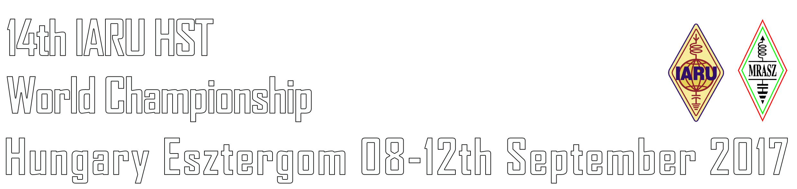
Letter of Intent

We: _______________________________________________ ____________
(Full name of IARU member Society) (Official abbrevation)
intend to participate in the 14th IARU HST World Championship in Esztergom, Hungary. Our delegation will be as follows:
1. Number of competitors: _______________
2. Number of officials (if not competitors): _______________
3.Number of guests/visitors: _______________
TOTAL NUMBER of delegation members in this event (1+2+3): _______________
Note: The referees of the International Jury shall not be included in the above number. They will be personally invited.
Contact person for the correspondence with the orgaizing committee
Name & Callsign: _____________________________________________________
Telephone number (including country and area codes): ______________________
E-mail: _____________________________________________________________

Date: _______________________
On behalf of the society:
________________________________________________
(Name, Position in the society, Signature)

Please fill in and send it back not later than 8th March by email to: info@hst2017.org

